**Week 9: Tutorial**

| Job Seeking Skills • Dress code and appearance • Effective body language in a job interview • Understanding appropriate   interview etiquette • Exercises on job-seeking skills |
| --- |
| **Practice on job interview questions** |
|  |

1. Dress code and Appearance (Adopted from: Textbook Page 137)

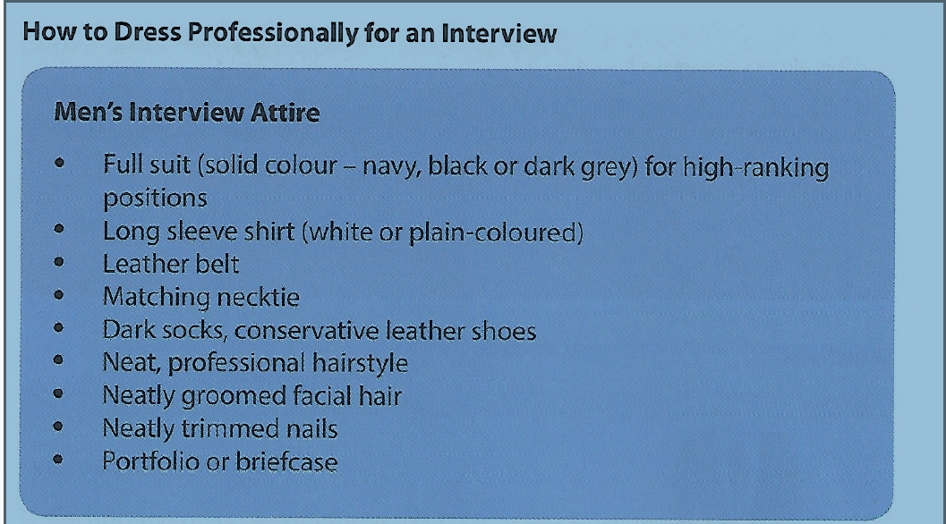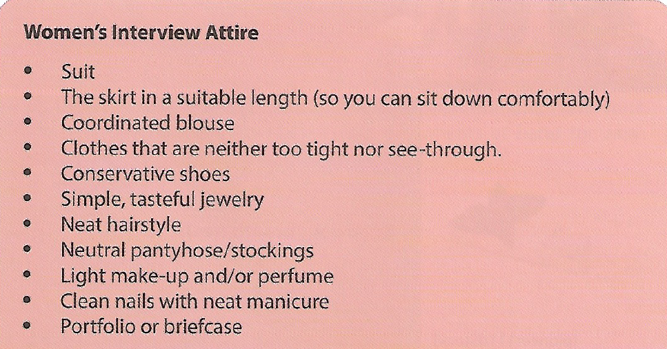

**2. Effective body language in a job interview**

**Adopted from:**

<https://www.indeed.com/career-advice/interviewing/body-language-during-interview>

If you want your body language to project confidence in your next job interview, follow these steps:

1. Prepare in private.
2. Be aware in the waiting room.
3. Maintain good posture.
4. Keep your palms open.
5. Use effective eye contact.
6. Be responsive.

**1. Prepare in private**

Confident people are prepared. When you arrive at your interview, take some time to gather your documents, put your phone on silent and review any information before you enter the building. As soon as you walk inside, you will be interacting with company employees, and you immediately want to project confidence to them. Gather your thoughts and materials in a private place.

**2. Be aware in the waiting room**

Waiting for the interview to begin may seem like a great time to catch up on emails or send a text, but your time would be better spent introducing yourself to the receptionist and waiting patiently. If you're able to, choose a seat where you can see the door you think the interviewer will enter through so there is no awkwardness when they come in.

**3. Maintain good posture**

Once you are in the actual interview, keep your posture upright. Choose a straight-backed chair if possible, and keep your chin up and shoulders down. Great posture displays confidence.

**4. Keep your palms open**

You can use your hands to talk if that is natural for you, but make sure you keep your palms open as you do so. Open, upward-facing palms demonstrate you have nothing to hide and are confident in what you are saying.

**5. Use effective eye contact**

In terms of eye contact, treat the interviewer like an old friend. Make eye contact with them regularly, but look away when it feels natural to do so too. Always maintain eye contact when shaking hands.

**6. Be responsive**

Nod and smile to indicate you are listening to the interviewer when they are speaking. These actions show you understand what the interviewer is saying and agree with their statements.

**Tips for maintaining good body language during an interview**

Keep the following tips in mind during your next interview to make sure your body language indicates confidence, positivity and interest:

1. **Handshake:** You will likely shake hands with the interviewer. Your handshake should be firm and last a second or two.
2. **Posture:** Be aware of your posture at all times. Keep your shoulders back and down and your chin lifted. Practice this posture regularly so it is comfortable for you.
3. **Leg position:** Your legs should be still and uncrossed if possible. Crossing your legs may become uncomfortable, meaning you will need to stretch them out during the interview. This discomfort could be misinterpreted as disinterest in the interview.
4. **Restlessness:** If you have a nervous habit like jiggling your leg or tapping the table, do your best to suppress it. Restless habits can be distracting and may demonstrate nervousness or disinterest to the interviewer.
5. **Hand position:** If you are seated at a table or desk for the interview, keep your hands visible. This will demonstrate you have nothing to hide. If you are in a chair with nothing in front of you, keep your hands in your lap with the palms visible to indicate openness.
6. **Eye contact:** Eye contact should be moderated. Too little eye contact gives the appearance of nervousness, while too much is aggressive. Pretend you are having a comfortable conversation with a friend during the interview to guide your eye contact.
7. **Where to sit:** When in the waiting room, choose a chair that gives you the best visibility of people coming and going so you won't be caught unawares by the interviewer. In the interview, if given a choice of seats, choose a seat that will allow you to maintain excellent posture and able to comfortably make eye contact with everyone in the room.
8. **Your personal items:** If you have a briefcase or purse, set it on the floor by your side so you can easily grab it and shake hands with the hiring manager once the interview is over. If you plan to provide any documents or take notes, get those items out of your bag as soon as you enter the room so you don't disrupt the flow of conversation.
9. **Mirror:** We naturally tend to mirror the people with whom we are speaking. Be aware of this and mirror the interviewer's body language to set them at ease.
10. **Walking:** Walk smoothly and confidently between the waiting area and the interview room. Maintain excellent posture while walking and firmly hold on to your belongings so you don't drop anything.
11. **Breathe deeply:** Deep, even breaths calm the body and may help reduce the desire to perform nervous actions like jiggling your leg or drumming on your arm.
12. **Responsiveness:** Show you are interested in what the interviewer is saying by smiling, nodding and leaning forward when they are speaking.

**3. Understanding appropriate interview etiquette**

**Adopted from:**

<https://www.indeed.com/career-advice/interviewing/job-interview-etiquette>

## A. Be punctual for job interview

## -Arrive at the job interview session punctually shows respect and portray a good image to the company and the interviewer(s).

## B. Dress to impress

## -Dress professiaonlly to impress the interviewer(s) and show sign a respect to them.

## C. Know their names

## -Knowing and rememebering the names of the interviewer(s) puts you in a added advantage during the interview especially group interview where you may have to “compete” with other job applicants.

## D. Turn off mobile phones and other electornic gadgets

## -It is very important to sign off any electronic gadgets such as mobile phone to prevent interruption during the process of interview.

## - It is a sign of respect to the interviewer(s).

## E. Portray appropriate body language

* Do sit up straight and look genuinely interested.
* Do keep good eye contact.
* Don’t slouch.
* Don’t lean forward, towards the interviewer.
* Don’t point.
* Don’t cross your arms.
* Don’t stare for too long.
* Don’t fidget.
* Don’t keep looking around the room.

## F. Show gratitude

## -End the interview with a “ Thank you” to the interview(s).

**Basic interview questions:**

1. [Tell me about yourself](https://www.monster.com/career-advice/article/intreview-tell-me-about-yourself).
2. What are your [strengths](https://www.monster.com/career-advice/article/focus-on-your-strengths)?
3. What are your [weaknesses](https://www.monster.com/career-advice/article/recruiter-roundtable-the-weakness-question-hot-jobs)?
4. [Why do you want this job?](https://www.monster.com/career-advice/article/how-to-answer-question-why-do-I-want-this-job)
5. [Where would you like to be in your career five years from now?](https://www.monster.com/career-advice/article/how-to-answer-job-interview-question-where-do-want-to-be-in-5-years)
6. [What's your ideal company?](https://www.monster.com/career-advice/article/how-to-answer-job-interview-question-your-ideal-company)
7. [What attracted you to this company?](https://www.monster.com/career-advice/article/how-to-answer-question-why-do-I-want-to-work-here)
8. [Why should we hire you?](https://www.monster.com/career-advice/article/why-should-we-hire-you)
9. [What did you like least about your last job?](https://www.monster.com/career-advice/article/like-least-about-your-last-job)
10. When were you most satisfied in your job?
11. What can you do for us that other candidates can't?
12. What were the responsibilities of your last position?
13. [Why are you leaving your present job?](https://www.monster.com/career-advice/article/why-did-you-leave)
14. What do you know about this industry?
15. What do you know about our company?
16. Are you willing to relocate?
17. [Do you have any questions for me?](https://www.monster.com/career-advice/article/interview-do-you-have-any-questions)